This tutorial uses a Netgear GT108TV2 in order to mark the DHCPv6 request with a CoS of 6. This is required by Orange (in most areas) to get the address. If you can get an address without CoS 6 you will not need this switch. Continue with the setup from “Part 2 - pfSense Setup” further along this guide

This guide deals just with Internet, there are many post that show how to configure TV and phone but I need neither

Part 1 - Switch Setup

We will use port 1 for the connect to ONT and port 2 to connect to the pfSense WAN

First create the VLAN required

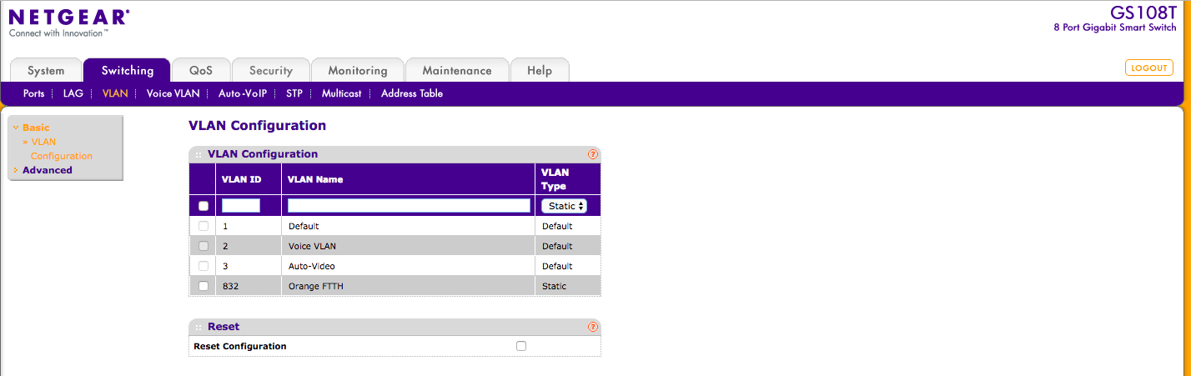

TAG ports 1 & 2 to the VLAN just created

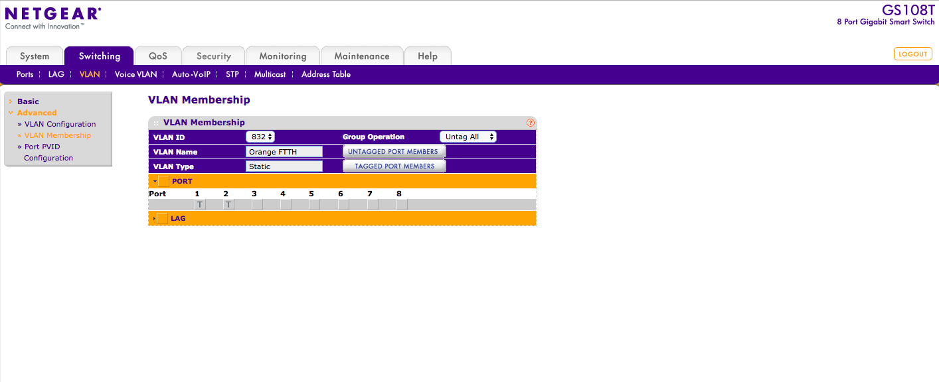

Mark ports 1 an 2 as VLAN only

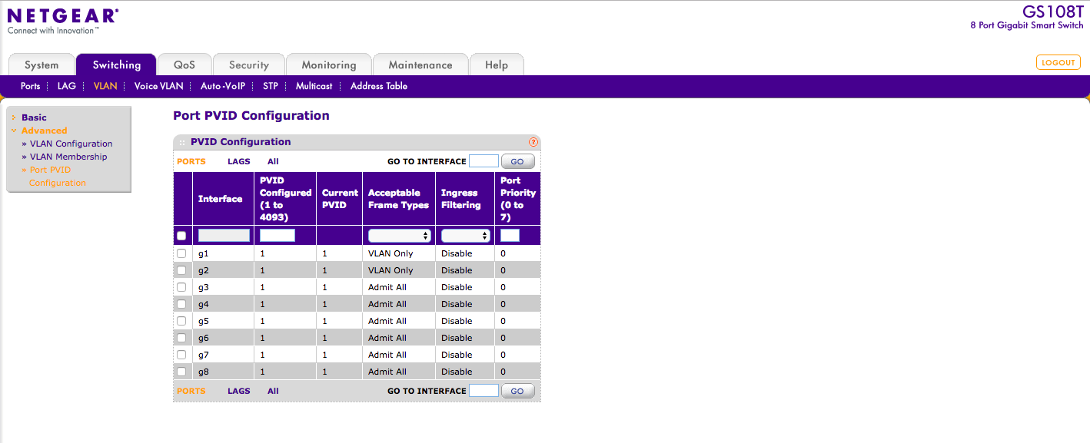

Now we go to QoS and Diffserv to set up the class and policies. The port are those UDP ports used by DHCPv6. Here we are saying which packets to add CoS to.

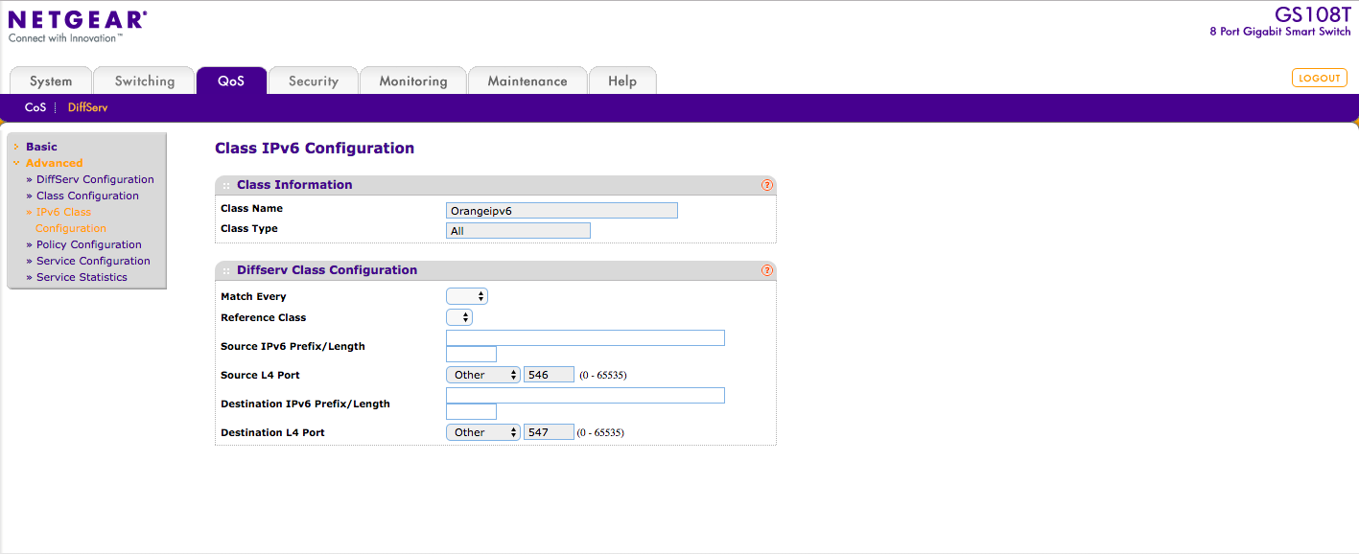

Now we explain how to mark the packets

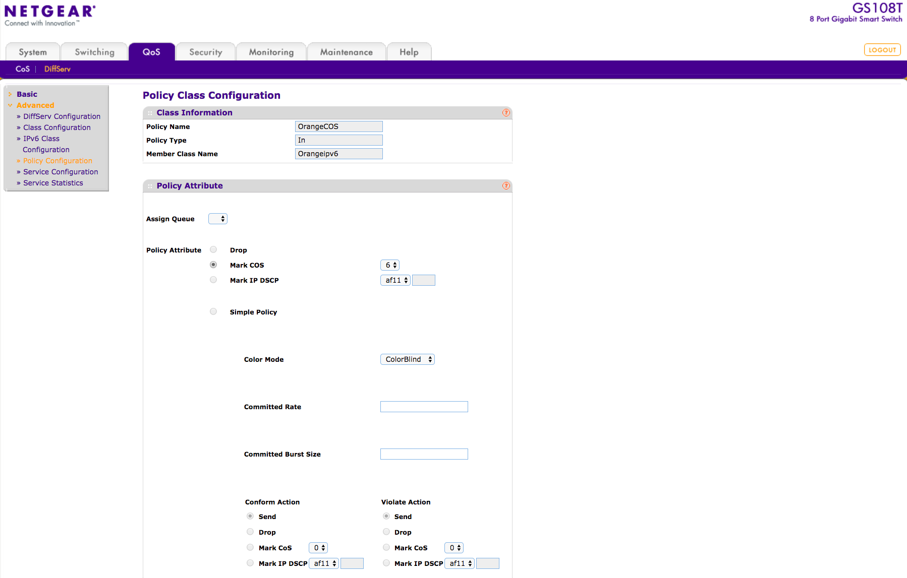

Now we must tell the switch which port to apply the policy to. Remember the switch applies the policy on inbound. Port 2 is connected to the WAN of pfSense

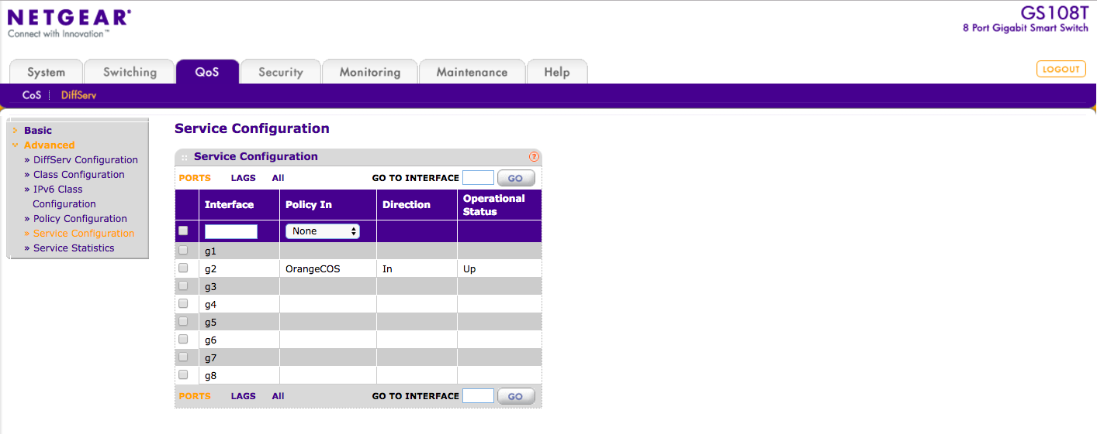

Part 2 - pfSense Setup

Now we need to copy some new files over to the pfsense/FreeBsd system

The directory structure of what is needed is here. All the files required are included in the OrangeFTTH.zip file attached

Ensure you copy them to the indicated directories shown here. Some make not exist so create them.

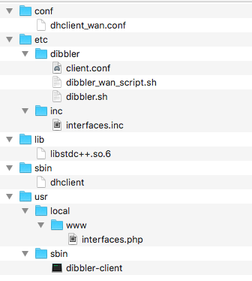

Then you must modify

dhclinet_wan.conf

change the line

send rfc3118-auth 00:00:00:00:00:00:00:00:00:00:00:xx:xx:xx:xx:xx:xx:xx:xx:xx:xx:xx;

to replace bold with your credentials (see my earlier post)

client.conf

change the line

option 11 hex 00:00:00:00:00:00:00:00:00:00:00:xx:xx:xx:xx:xx:xx:xx:xx:xx:xx:xx

to replace bold with your credentials
Its not a typo the line is there twice for a reason as it seems to be needed at present.

Also in both files change the interface names eg igb0_vlan832 and igb0 to match those of your installation

Now we need to log into the pfSense GUI and make the relevant options in Interface/WAN

Select IPV6 configuration as shown below

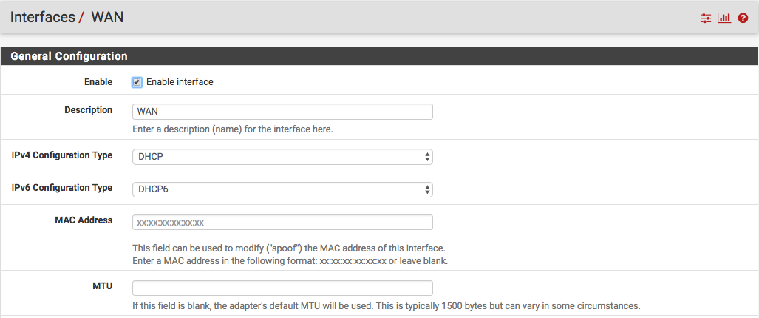

This will now present a new option radio button for dibbler. Select it and also “do not wait for a RA”

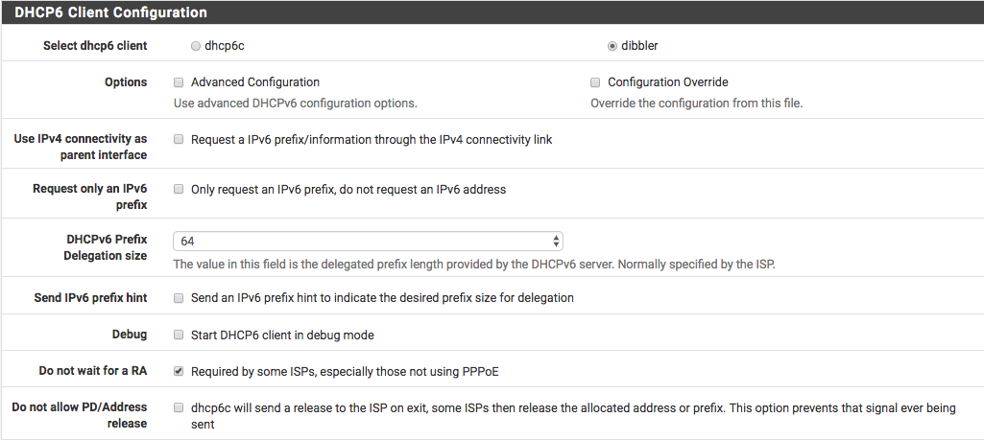

Hit save and your done almost.

Once the IPv6 is up and running in order to ensure you keep your ipv6 prefix (not guaranteed but should make it more likely) you keep VAR in RAM like me then ssh into the pfSense instance and issue

cp /var/lib/dibbler/client-duid /conf/dibbler-duid

that will make a copy of the duid

If VAR is not in RAM this is not needed.

